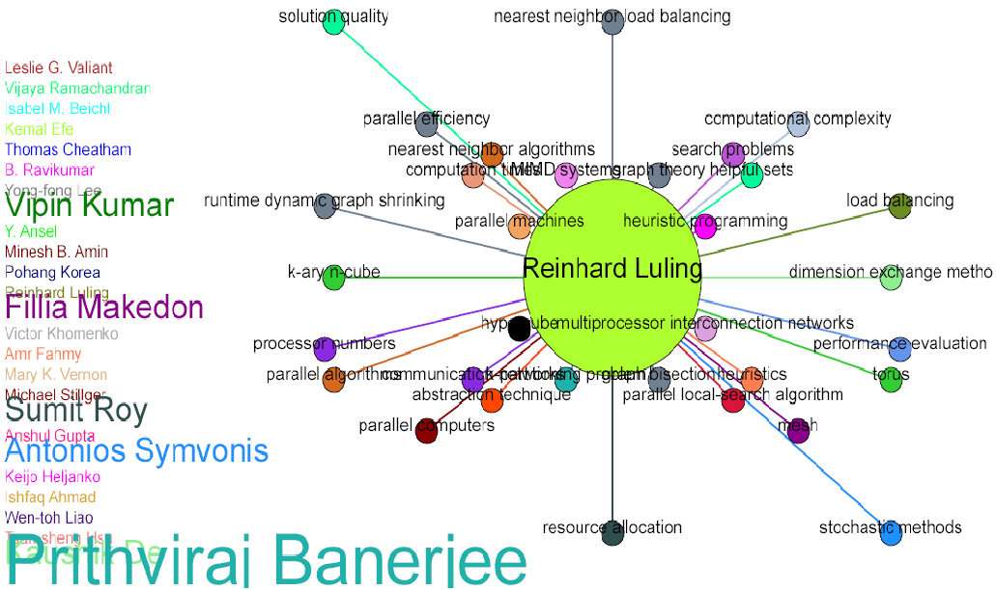

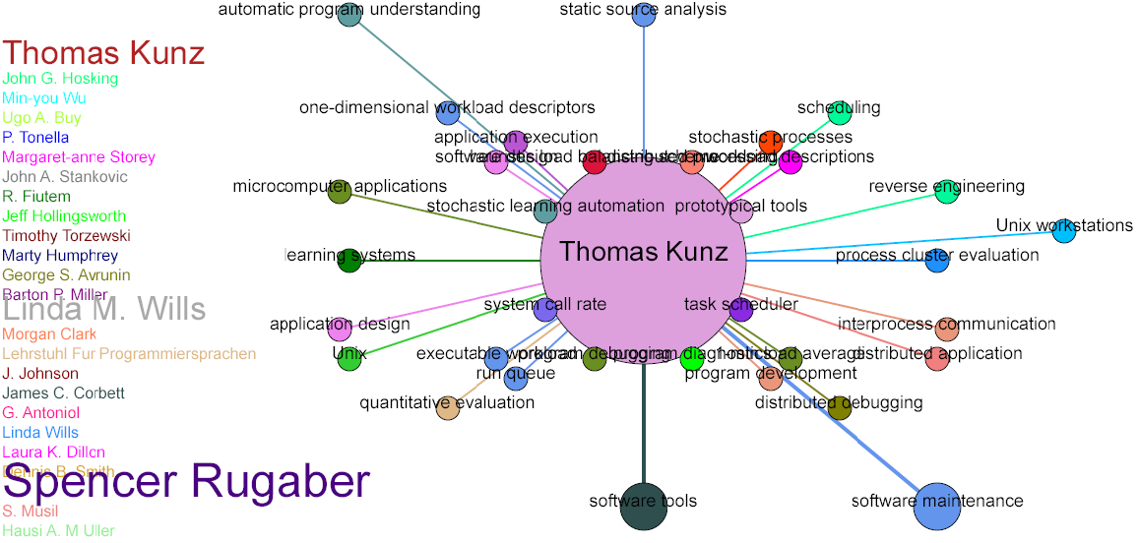---

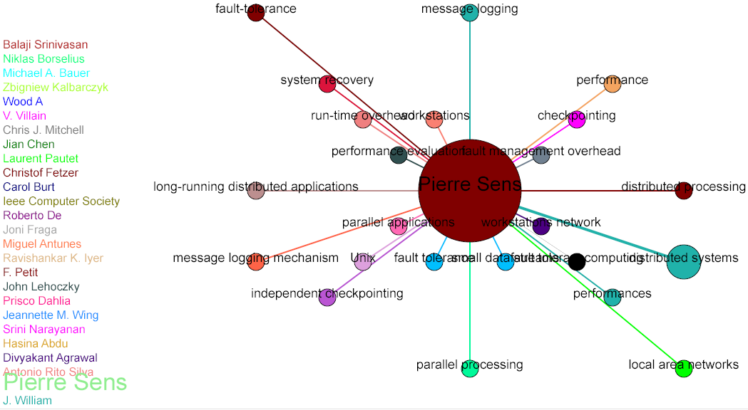

**Click on distributed system node**

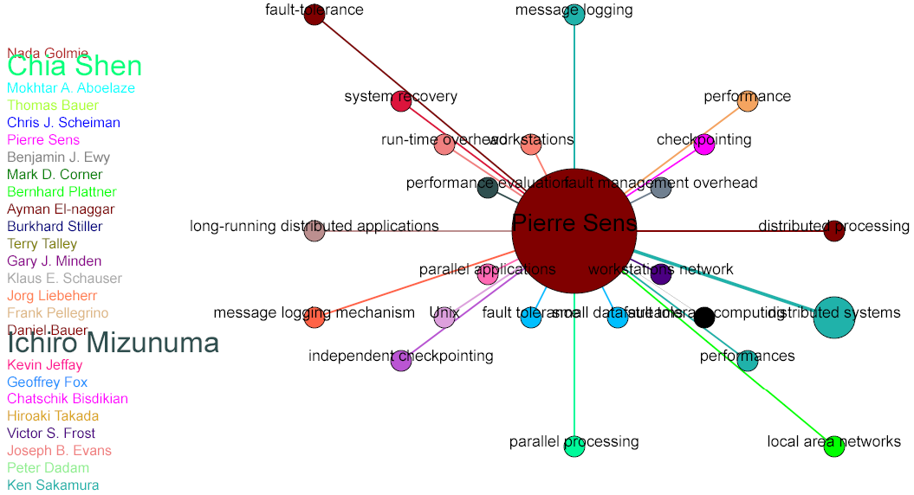

**Click on local area network node**

The central crux of visualization is to present a plethora of information in a limited space delivering a strong impact of understanding of tacit knowledge. It is evident from the figure-3 and figure-4, the author *Pierre Sens* has produced many scholarly articles covering a wide range of topics. These topics broadly categorize into system architecture to system networks. The star topology resembling network is designed with a motley of colors being rendered in a randomly fashion to deliver a delineate view. We are impressed by this fact that no visualization is complete without colors. Historically colors have been playing an important role in our day to day life. In almost every culture and society, it is still believed that different colors reflect diversified meaning in human life. In ancient culture alike Egyptian, Samarian, Mayan (and many more), it was revealed that the societies believed in the postulate that colors can affect man’s being for every color with certain signals while permeating through human’s [neurological system](http://shamelabboush.hubpages.com/hub/NLP-The-Art-of-Communication-Understanding-Others), psychological conditions and mental state. It was also believed that colors can alter their opinions and argument while introducing a novelty in their lives with the underlying assumption that every single color has unique interpretation in itself. Motivated from these historical perspectives, we can state that no visualization is complete without launching of motley of colors in an appropriate fashion. We adopted more than five dozen of colors being rendered in a uniform random distribution fashion. The explanation of the design is embodied in a way that the size of the node as well as width of the connecting arcs is a visual representation of number of publications of corresponding authors. As the number of publication of an author in a specific domain of topic is increased, the node size of the topic with the width of its corresponding arc is also increased correspondingly. However, it is not sufficient to limit ourselves only to a single level of visualization, rather there is a need to explore who else is involved in any specific are of topic. We can illustrate this fact by highlighting the node “Distributed Node” and “Local Area Network”. A mouse over event will reveal the corresponding list of the authors which are related to this topic. The array of authors is not only restricted to mere display of names of the researcher but the size of the font indicates that how much that corresponding author is involved in that specific node. For example, when we click on “Local Area Network” node, it displays a list of authors. Some are bold with relatively larger font size indicating that this author is more involved in scholarly articles of “Local Area Network”. A small font size indicates that the author produced less number of publications comparatively. This style of visualization enable us to deliver two types of information, first is related to expert topics any author is involved in, the second stream of information is array of related authors. The system is designed in a way that if we click on any of the link from the array of author list, it will jump to that author with his/her expert topics. In this way, our system is enabled to deliver a very fast and quick response over finding any specific area with its list of authors.